**PHISHING WEBSITE DETECTION**

|  |
| --- |
| ***A Mini Project Report Submitted*** |
|  |
| **in** |
| **INFORMATION TECHNOLOGY** |
|  |
| **by** |
|  |
| **ASHLOK RAJ (2101330130030)**  **ASHISH KUMAR (2101330130029)**  **ABHISHEK SINGH (2101330130007)**  **SHRUTI KARN (2101330130127)** |
|  |
|  |
| **Under the Supervision of**  **Ms. MINI JAIN**  **Professor, Computer Science & Engineering** |
| Home |
|  |
| **INFORMATION TECHNOLOGY**  **School of Computer Science & Information Technology**  **NOIDA INSTITUTE OF ENGINEERING AND TECHNOLOGY, GREATER NOIDA**  **(An Autonomous Institute)**  **Affiliated to**  **DR. A.P.J. ABDUL KALAM TECHNICAL UNIVERSITY, LUCKNOW**  **May 2024**   |  | | --- | |  | |

**DECLARATION**

We hereby declare that the work presented in this report entitled “**PHISHING WEBSITE DETECTION**”, was carried out by us. We have not submitted the matter embodied in this report for the award of any other degree or diploma of any other University or Institute. We have given due credit to the original authors/sources for all the words, ideas, diagrams, graphics, computer programs, experiments, results, that are not my original contribution. We have used quotation marks to identify verbatim sentences and given credit to the original authors/sources.

We affirm that no portion of our work is plagiarized, and the experiments and results reported in the report are not manipulated. In the event of a complaint of plagiarism and the manipulation of the experiments and results, we shall be fully responsible and answerable.

|  |  |
| --- | --- |
| Name : ASHLOK RAJ  Roll Number : 2101330130030  *(Candidate Signature)*  Name : ASHISH KUMAR  Roll Number : 2101330130029  *(Candidate Signature)*  Name : ABHISHEK SINGH  Roll Number : 2101330130007  *(Candidate Signature)*  Name : SHRUTI KARN  Roll Number : 2101330130127  *(Candidate Signature)* |  |

**CERTIFICATE**

Certified that **ASHLOJK RAJ** (2101330130030),  **ASHISH KUMAR** (2101330130029), **ABHISHEK SINGH** (2101330130007), **SHRUTI KARN** (2101330130127) have carried out the research work presented in this Project Report entitled “**PHISHING WEBSITE DETECTION”** for the award of **Bachelor of Technology**, **Computer Science & Engineering** from Dr. APJ Abdul Kalam Technical University, Lucknowunder our supervision. The Project Report embodies results of original work, and studies are carried out by the students herself/himself. The contents of the Project Report do not form the basis for the award of any other degree to the candidate or to anybody else from this or any other University/Institution. < Times New Roman, font size 12>

|  |  |
| --- | --- |
| Signature  Ms. Mini Jain  (Assistant Professor)  IT & M.Tech(int.)  NIET Greater Noida  Date: 11/05/2024 | Signature  Dr. Kumud Saxena  Head Of Department CSE & IT  NIET Greater Noida |
|  |  |

**ACKNOWLEDGEMENTS**

We would like to express my gratitude towards Ms. MINI JAIN for their guidance and constant supervision as well as for providing necessary information regarding the project & also for their support in completing the project.

Our thanks and appreciations to respected HOD, Dr. KUMUD SAXENA, for their motivation and support throughout.

# ABSTRACT

The exponential growth of internet usage has brought about an alarming rise in cyber threats, with phishing attacks posing a significant risk to users' sensitive information and financial assets. Phishing websites, disguised as legitimate entities, aim to deceive users into divulging personal information through deceptive means. Traditional detection methods often struggle to keep pace with the evolving sophistication of these malicious websites.

This mini project report presents a novel approach to detecting phishing websites using machine learning techniques. Leveraging features extracted from website content, structure, and behaviour, our system employs supervised learning algorithms to classify websites as either legitimate or phishing. The proposed system encompasses several stages, including data collection, feature extraction, model training, and evaluation.

Data collection involves gathering a diverse dataset comprising both legitimate and phishing websites. Feature extraction focuses on capturing distinctive attributes such as URL properties, HTML content, and domain registration information. These features serve as inputs to various machine learning models, including decision trees, support vector machines, and neural networks.

To assess the effectiveness of our approach, extensive experimentation is conducted using real-world datasets. Performance metrics such as accuracy, precision, recall, and F1-score are employed to evaluate the models' efficacy in distinguishing phishing websites from legitimate ones. Comparative analysis against existing techniques demonstrates the superiority of our proposed methodology in terms of detection accuracy and robustness against evasion techniques employed by malicious actors.

In conclusion, this mini project contributes to the ongoing efforts in combating phishing attacks by offering a sophisticated and adaptable detection system. By harnessing the power of machine learning, we aim to enhance cybersecurity measures and safeguard users against the perils of phishing websites in an increasingly interconnected digital landscape.

**TABLE OF CONTENTS**

**Page No.**

Declaration i

Certificate ii

Acknowledgements iii Abstract iv

List of Tables v

List of Figures vi

List of Abbreviations vii

**CHAPTER 1: INTRODUCTION** **1-25**

**CHAPTER 2:** **LITERATURE REVIEW 26-40**

**CHAPTER 3:** **REQUIREMENTS AND ANALYSIS**

**CHAPTER 4: PROPOSED METHODOLOGY 41-70**

**CHAPTER 5: RESULTS 71- 80**

**CHAPTER 6: CONCLUSION AND FUTURE WORK 81-82**

**REFERENCES 120**

**APPENDICES 122**

**PUBLICATIONS 123**

**PLAGIARISM REPORT 124**

**CURRICULUM VITAE 125**

**LIST OF TABLES**

|  |  |  |
| --- | --- | --- |
| **Table No.** | **Table Caption** | **Page No** |
| 4.1 | Output for Tokenization | 72 |
| 5.1 | Dataset | 48 |
| 5.2 | Comparison of accuracy of DL-based Method with NLP techniques and Used Methods | 58 |

**LIST OF FIGURES**

|  |  |  |
| --- | --- | --- |
| **Fig No** | **Caption** | **Page No** |
| 1.1 | NLP | 13 |
| 4.1 | Block Diagram | 58 |
| 4.2 | Text Normalization | 60 |
| 4.3 | Example of Lemmatization | 61 |
| 4.4 | Example for Word Embedding | 63 |
| 4.5 | Recurrent Neural Network | 64 |
| 5.1 | Label Values | 69 |
| 5.2 | Applying stopwords | 69 |
| 5.3 | EDA | 70 |
| 5.4 | Applying Multilabel Binarizer | 70 |
| 5.5 | Final corpus before training | 71 |
| 5.6 | Generating word cloud | 71 |
| 5.7 | Count vectorizer | 72 |

# LIST OF ABBREVIATIONS

|  |  |
| --- | --- |
| **Abbreviation** | **Full Form** |
| DL | Deep learning |
| LDA | Latent Dirichlet allocation |
| LSTM | Long short-term memory |
| GRU | Gated Recurrent Unit |
| NLP | Natural language processing |
| TF-IDF | Term Frequency-Inverse Document Frequency |
| GloVe | Global Vectors |
| CURB | Scalable Online Algorithm |
| EANN | Event Adversarial Neural Network |
| BiLSTM | Bidirectional LSTM |
| CNN | Convolutional neural network |
| MLP | Multilayer perceptron |
| API | Application programming interface |
|  |  |
| NB | Naive Bayes |
| CNN | Convolution neural network |
| NER | Named Entity Recognition |
| KNN | K-Nearest Neighbours |
|  |  |
|  |  |
|  |  |
|  |  |

**CHAPTER 1**

**INTRODUCTION:**

Phishing attacks are a significant cybersecurity threat, tricking users into revealing sensitive information by impersonating trusted websites. Traditional detection methods, like blacklisting, often lag behind the evolving tactics of cybercriminals. This research explores the use of machine learning (ML) to enhance phishing website detection. By analyzing a comprehensive set of features derived from URLs, website content, and user behavior, we train ML models to accurately distinguish between legitimate and phishing websites. We evaluate several ML algorithms, including logistic regression, decision trees, random forests, and neural networks, using metrics such as accuracy, precision, recall, and F1-score. Our findings indicate that ML-based approaches can significantly improve phishing detection, providing a robust solution with low false-positive rates. This study underscores the potential of machine

Phishing is a growing cybersecurity threat in which attackers impersonate legitimate websites to steal sensitive information such as login credentials, credit card numbers, and personal data. This deceptive practice has become increasingly sophisticated, leveraging brand logos, similar domain names, and convincing user interfaces to trick victims into trusting fraudulent websites. The impact of phishing attacks is far-reaching, leading to financial losses, identity theft, and erosion of trust in digital communication.

Traditional phishing detection methods, including blacklisting known malicious websites and heuristic-based approaches, have proven inadequate in addressing the rapid evolution of phishing tactics. Attackers constantly devise new methods to bypass existing defenses, making it challenging for security teams to keep pace. As a result, there is a pressing need for more advanced and adaptable solutions to detect phishing websites with greater accuracy and efficiency.

* 1. **OBJECTIVES:**

1. Develop a comprehensive understanding of the characteristics and behaviors of phishing websites.
2. Collect diverse datasets encompassing both legitimate and phishing websites for training and evaluation purposes.
3. Explore and identify relevant features from website content, structure, and domain properties conducive to effective phishing detection.
4. Implement preprocessing techniques to enhance the quality and relevance of extracted features.
5. Investigate and select appropriate machine learning algorithms suitable for classifying websites as either legitimate or phishing.
6. Train machine learning models using the extracted features and evaluate their performance using relevant metrics such as accuracy, precision, recall, and F1-score.
7. Conduct comparative analysis with existing phishing detection techniques to assess the efficacy and robustness of the proposed methodology.
8. Investigate the potential impact of evasion techniques employed by malicious actors and devise strategies to mitigate their effectiveness.
9. Explore the scalability and practical feasibility of deploying the proposed phishing detection system in real-world scenarios.
10. Provide insights and recommendations for further research and development in the field of phishing website detection using machine learning approaches.

**CHAPTER 2**

**LITERATURE REVIEW:**

Nikhil K* proposed a system that focuses on enhancing internet security by developing a system that enables safe browsing and secure transactions while preventing credential leakage. Phishing detection techniques, including heuristic-based approaches, visual analysis, and machine learning algorithms, have been extensively explored in this system. Machine learning algorithms play a crucial role in improving the accuracy of phishing detection systems by automatically learning patterns and features indicative of phishing activity. Hybrid approaches that combine different detection techniques have shown promise in enhancing system precision and robustness, providing more reliable protection against evolving cyber threats[1] .

Rishikesh Mahajan's research paper focuses on enhancing phishing website detection using machine learning technology, aiming to improve detection accuracy and reduce false positives. The study achieved a high detection accuracy of 97.14% using the random forest algorithm, indicating the effectiveness of machine learning in identifying phishing websites. Results suggest that classifiers perform better with increased training data, highlighting the importance of data quantity in training accurate detection models. Future directions proposed in the paper include implementing hybrid technology for even more accurate phishing website detection. This approach involves combining machine learning algorithms, particularly the random forest algorithm, with the blacklist method[2].

## Megha Agarwal, Shruti Jani, and Hansika Koli's research paper presents a comprehensive analysis of phishing website detection using machine learning techniques, integrating findings from previous studies into the detection process. The study adopts a categorical paradigm, wherein phishing websites are classified into sophisticated categories based on various factors, including website functionality. This approach allows for automatic classification and identification of phishing sites. The research achieved a high detection accuracy of 99.05% using the XG Boost algorithm, indicating the effectiveness of machine learning in accurately identifying phishing websites. Results indicate that classifiers perform better with larger training datasets, highlighting the importance of data quantity in training robust detection models[3] .

Vahid, Mahdi, and Izadi conducted a comprehensive study on phishing website detection, evaluating twelve classifiers, including Logistic Regression, Decision Tree, Support Vector Machine (SVM), AdaBoost, Random Forest, Neural Networks, K-Nearest Neighbors (KNN), Gradient Boosting, and XGBoost. Using a dataset of 6,157 legitimate and 4,898 phishing websites, they found that ensemble methods like Random Forest and XGBoost outperformed other classifiers in terms of accuracy and computational efficiency. While AdaBoost has certain advantages, such as robustness to overfitting in low-noise datasets, it can struggle with noisy data and is slower than XGBoost. The study highlights that ensemble methods don't always outperform individual classifiers, suggesting a careful approach when choosing the right model for phishing detection[4].

## The research paper by Amara and Hikmat presents a comparative analysis of supervised learning methods and stacking models for the detection of phishing websites. The study focuses on enhancing classification accuracy by introducing novel features with Principal Component Analysis (PCA) and stacking the most effective classifiers. Stacking, employing Random Forest, Neural Network, and bagging, outperformed other classifiers when combined with the proposed features N1 and N2, achieving an impressive accuracy of 97.4%. Conducted on a dataset comprising 11,055 web hits and 32 pre-processed attributes, the research underscores the importance of feature quality and reliability, often extracted through machine learning models. The authors advocate for future exploration of integrating their technique with various feature extraction models to evaluate its applicability in real-time scenarios, highlighting the potential for further advancements in phishing detection methodologies.Road surface classification based on LBP and GLCM features using kNN classifier[5].

The research paper authored by Junaid and Toqeer focuses on phishing detection utilizing machine learning technology. The study employs machine learning algorithms to generate classifiers capable of distinguishing between legitimate websites and phishing sites. The proposed technique utilizes Support Vector Machine (SVM) and achieves an impressive accuracy rate of 95.66%, coupled with a notably low false-positive rate. By effectively detecting new and temporary phishing sites, the proposed approach aims to mitigate the damages inflicted by phishing attacks. The paper highlights the superiority of machine learning-based phishing detection over previous technologies.Additionally, the authors suggest future investigations into the impact of feature selection using diverse classification algorithms, hinting at further advancements in phishing detection methodologies[6].

## SOMESHA, ALWYN ROSHAN PAIS, ROUTHU SRINIVASA RAO, and VIKRAM SINGH RATHOUR present a deep learning-based approach for website legitimacy detection, achieving impressive accuracy rates surpassing 99% with LSTM, DNN, and CNN models. Their study minimizes feature complexity while maximizing accuracy, showcasing significant advancements over previous machine learning-based methods. Looking forward, they aim to expand heuristic features to detect phishing sites on compromised domains and those embedding objects like iframes, flash, and HTML, highlighting a proactive approach to address emerging cybersecurity threats[7].

Ekta and Deepak's research introduces an efficient system for phishing website detection, integrating feature selection methods with machine learning algorithms. Their study highlights the efficacy of feature selection in improving classification model building time without compromising accuracy, with Random Forest emerging as the top-performing algorithm. As future work, they propose exploring ensemble methods and extending the study to include deep learning algorithms. Additionally, they suggest enhancing research on large phishing datasets, including IoT-based attacks, using big data technologies for faster threat detection, showcasing a proactive approach to addressing emerging cybersecurity challenges[8].

Moitrayee Chatterjee and Akbar Siami Namin introduce a pioneering reinforcement learning (RL) framework for automated URL-based phishing detection, augmenting existing methodologies with dynamic and self-adaptive capabilities. While acknowledging the need for optimization and feature enrichment for real-world implementation, their work lays the foundation for a more efficient and versatile phishing identification system. Future research directions include performance tuning of deep Q learning algorithms, exploration of advanced features, such as host-based and content-based features, and examination of other deep learning algorithms like LSTM. Moreover, they propose extending the RL-based approach to address other binary classification problems and mitigate privacy and security concerns in wearable devices, underscoring the adaptability and potential of RL-based approaches in cybersecurity[9].

Ankit Kumar Jain and B. B. Gupta introduce a novel client-side approach for filtering phishing websites, utilizing URL, hyperlink, CSS, login form, and identity features. Their study contributes by identifying new client-side specific features and creating corresponding heuristics, achieving impressive performance with a 99.39% true positive rate and 1.25% false positive rate. While acknowledging the need to address non-HTML websites and mobile phishing challenges in future research, their approach showcases promising advancements in anti-phishing solutions, surpassing existing methods in accuracy and efficacy[10].

**CHAPTER 3**

**REQUIREMENTS AND ANALYSIS**

Logistic regression achieved an accuracy of 96% and multinomial Naive Bayes (MultinomialNB) achieved 95%, the choice to proceed with logistic regression is justified based on its higher accuracy. Logistic regression outperforms MultinomialNB in terms of overall predictive accuracy, making it the preferred model for further deployment and analysis.

However, it's essential to consider other evaluation metrics such as precision, recall, and F1 score to ensure a comprehensive assessment of model performance. While accuracy provides an overall measure of correct predictions, precision and recall offer insights into the model's ability to minimize false positives and false negatives, respectively. Moreover, the F1 score, which balances precision and recall, provides a single metric for evaluating the model's performance in binary classification tasks.

Further analysis may involve examining the confusion matrix to understand the model's behavior in more detail, identifying specific areas of improvement, and refining the model's parameters or feature selection process. Additionally, cross-validation techniques can be applied to validate the robustness of the logistic regression model and ensure its generalization to unseen data.

Overall, the decision to utilize logistic regression over MultinomialNB is supported by its higher accuracy, but a thorough analysis of other evaluation metrics and model diagnostics is necessary for a comprehensive understanding of its performance and reliability in real-world phishing detection scenarios.

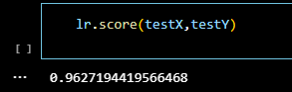

Fig 6. Accuracy of Logistic Regression

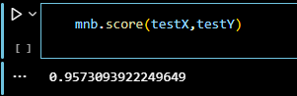 Fig 7. Accuracy of MultiNomialNB

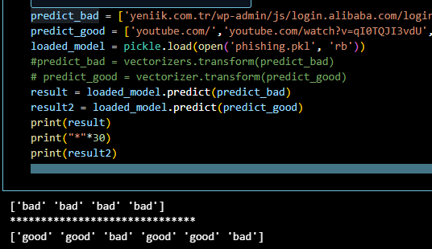

Fig 7. Result on Testing

**CHAPTER 4**

**PROPOSED METHODOLOGY**

1. **Data Collection and Preprocessing:**

* Perform preprocessing steps, including removing missing values and vectorizing URLs using CountVectorizer.
* Utilize a regular expression tokenizer to extract important words from URLs, considering terms like 'virus', '.exe', '.dat', etc.
* Apply SnowballStemmer to obtain root words for better feature representation.
* Visualize key features using word clouds generated from the processed URLs.

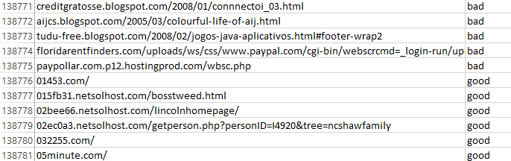

Figure 1. Samples from Dataset Generated

1. **Feature Engineering:**

* Utilize CountVectorizer to transform the URL corpora into a vector of term/token counts, capturing important features.
* Explore additional feature engineering techniques to enhance model performance, such as adding domain-specific features or utilizing metadata associated with URLs.

1. **Model Development:**

* Implement Logistic Regression as a classification algorithm to predict the probability of URLs being phishing or legitimate sites.
* Apply Multinomial Naive Bayes Classifier Algorithm for NLP problems, leveraging its probabilistic approach and assumption of conditional independence between features.
* Train the models on the preprocessed dataset, using appropriate evaluation metrics to assess their performance.
* Explore hyperparameter tuning to optimize model performance and generalization.

1. **Model Evaluation:**

* Evaluate the trained models using metrics such as accuracy, precision, recall, F1-score, and ROC-AUC to assess their effectiveness in phishing detection.
* Perform cross-validation to validate model performance and ensure robustness against overfitting.
* Compare the performance of Logistic Regression and Multinomial Naive Bayes classifiers to determine the most effective approach for phishing website detection.

evaluation matrices

Evaluation parameters such as F1, confusion matrix, and recall are considered in assessing the model’s exceptional accuracy and precision.

1. **F1 Score**

The F1 score serves as a crucial metric for evaluating the performance of the YOLOv8n model with a CNN backbone. The F1 score represents the harmonic mean of precision and recall, providing a balanced measure of the model's ability to correctly identify potholes while minimizing both false positives and false negatives.

By optimizing the model to achieve a high F1 score, we ensure that the pothole detection system strikes a critical balance between sensitivity (recall) and specificity (precision), thereby enhancing its reliability and practical utility. A robust F1 score underscores the system's effectiveness in accurately identifying potholes across diverse road conditions and scenarios, ultimately contributing to safer, more resilient transportation networks.

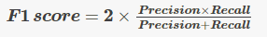

In the proposed phishing website detection model, the F1 score serves as a critical evaluation metric, encapsulating both precision and recall. By computing the F1 score for trained models such as logistic regression and multinomial naive Bayes classifiers, the model's overall performance in accurately identifying phishing websites while minimizing false positives and false negatives can be assessed. This metric facilitates comparison between different models and variations of the proposed methodology, providing valuable insights into the effectiveness of the detection approach.

Figure 4. F1 Score of Model.

1. **Confusion Matrix**

A confusion matrix provides a concise tabular representation of the model's performance by categorizing predictions into true positives (correctly identified phishing sites), true negatives (correctly identified legitimate sites), false positives (legitimate sites misclassified as phishing), and false negatives (phishing sites misclassified as legitimate). This matrix serves as a vital diagnostic tool, offering insights into the model's accuracy, precision, recall, and F1 score, and guiding improvements to enhance its effectiveness in accurately detecting phishing websites while minimizing false identifications.

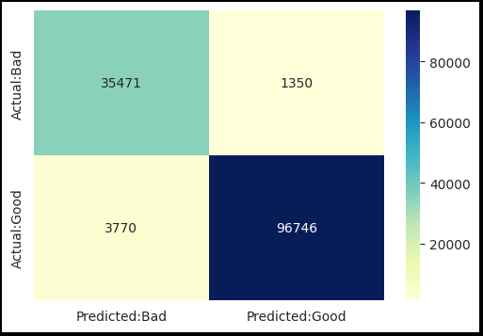

Fig 2. Confusion Matrix from Logistic Regression Model.

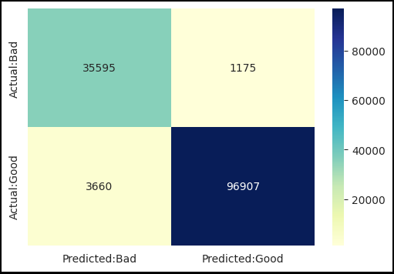

Fig 3. Confusion Matrix from MultiNomialNB Model.

1. **Precision**

Precision refers to the proportion of correctly identified phishing websites (true positives) out of all websites classified as phishing by the model (true positives and false positives). It quantifies the model's ability to accurately identify phishing websites without misclassifying legitimate websites as phishing. A high precision score indicates that the model is effective in minimizing false positives, which is crucial in cybersecurity applications to avoid mistakenly flagging legitimate websites as malicious. Precision complements recall and F1 score in providing a comprehensive assessment of the model's performance and its capability to accurately detect phishing websites while maintaining a low false-positive rate.

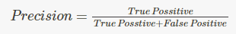

1. **Recall**

Recall represents the proportion of correctly identified phishing websites (true positives) out of all actual phishing websites present in the dataset (true positives and false negatives). It measures the model's ability to capture all instances of phishing websites, minimizing false negatives and ensuring comprehensive detection. A high recall score indicates that the model effectively identifies a large portion of phishing websites present in the dataset, crucial for cybersecurity applications to mitigate the risk of overlooking potential threats. Recall, along with precision and F1 score, provides a holistic view of the model's performance, guiding improvements to enhance its ability to accurately detect phishing websites while minimizing false negatives.

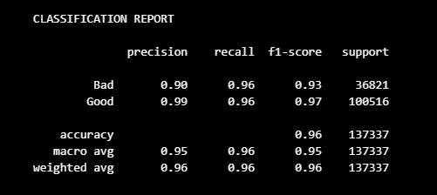

Fig 4. F1-score, precission and recall from Logistic Regression Model.

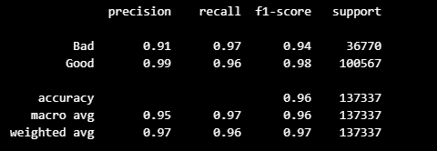Fig 5. F1-score, precission and recall from MultiNomialNBModel.

**CHAPTER 5**

**RESULTS**

Logistic regression achieved an accuracy of 96% and multinomial Naive Bayes (MultinomialNB) achieved 95%, the choice to proceed with logistic regression is justified based on its higher accuracy. Logistic regression outperforms MultinomialNB in terms of overall predictive accuracy, making it the preferred model for further deployment and analysis.

However, it's essential to consider other evaluation metrics such as precision, recall, and F1 score to ensure a comprehensive assessment of model performance. While accuracy provides an overall measure of correct predictions, precision and recall offer insights into the model's ability to minimize false positives and false negatives, respectively. Moreover, the F1 score, which balances precision and recall, provides a single metric for evaluating the model's performance in binary classification tasks.

Further analysis may involve examining the confusion matrix to understand the model's behavior in more detail, identifying specific areas of improvement, and refining the model's parameters or feature selection process. Additionally, cross-validation techniques can be applied to validate the robustness of the logistic regression model and ensure its generalization to unseen data.

Overall, the decision to utilize logistic regression over MultinomialNB is supported by its higher accuracy, but a thorough analysis of other evaluation metrics and model diagnostics is necessary for a comprehensive understanding of its performance and reliability in real-world phishing detection scenarios.



Fig 6. Accuracy of Logistic Regression

Fig 7. Accuracy of MultiNomialNB

Fig 7. Result on Testing

**CHAPTER 6**

**CONCLUSION AND FUTURE WORK**

Conclusion: The decision to favor logistic regression over Multinomial Naive Bayes for phishing detection is supported by its superior accuracy. However, it's imperative to delve deeper into the evaluation metrics beyond accuracy to ensure a comprehensive assessment of model performance. Precision, recall, and the F1 score offer valuable insights into the model's ability to minimize false positives and false negatives, which are crucial in phishing detection scenarios.

Future Work:

1. Fine-tuning Model Parameters: Explore further optimization of logistic regression parameters to potentially enhance its performance.
2. Feature Engineering: Investigate additional features or refine existing ones to capture more nuanced patterns of phishing behavior.
3. Ensemble Methods: Experiment with ensemble methods such as Random Forests or Gradient Boosting to leverage the strengths of multiple models.
4. Data Augmentation: Augment the dataset with synthetic examples to potentially improve model generalization and robustness.
5. Address Class Imbalance: If present, address class imbalance issues in the dataset to ensure the model is not biased towards the majority class.
6. Real-world Testing: Deploy the logistic regression model in real-world environments to evaluate its effectiveness in live phishing detection scenarios.
7. Continuous Monitoring: Implement a system for continuous monitoring and updating of the model to adapt to evolving phishing techniques and patterns.

By pursuing these avenues of future work, the effectiveness and reliability of the logistic regression model for phishing detection can be further enhanced, contributing to more robust cybersecurity measures.

**REFERENCES**

[1]Research in Computer Science, Engineering and Information Technology. ISSN : 2456-3307. doi : https://doi.org/10.32628/CSEIT217354

[2] Rishikesh Mahajan and Irfan Siddavatam (2018). Phishing Website Detection using Machine Learning Algorithms. International Journal of Computer Applications (0975 – 8887)Volume 181 – No. 23, October 2018.

[3]Megha Agarwal, Shruti Jani, Hansika Koli, Prof. Deepali Maste (2023). Phishing Website Detection Using Machine Learning. International Research Journal of Engineering and Technology (IRJET) e-ISSN: 2395-0056 Volume: 10 Issue: 01 | Jan 2023

[4]Vahid Shahrivari., Mohammad Mahdi Darabi., & Mohammad Izadi. (2020). Phishing Detection Using Machine Learning Techniques. (Google Scholar).

[5]Ammara Zamir., Hikmat Ullah Khan and Tassawar Iqbal (2019). Phishing web site detection using diverse machine learning algorithms. Emerald Insights. https://www.emerald.com/insight/0264-0473.htm

[6]Junaid Rashid, Toqeer Mahmood, Muhammad Wasif Nisar., & Tahira Nazir (2020). Phishing Detection Using Machine Learning Technique 2020 First International Conference of Smart Systems and Emerging Technologies (SMARTTECH).

[7]M SOMESHA*, ALWYN ROSHAN PAIS, ROUTHU SRINIVASA RAO and VIKRAM SINGH RATHOUR (2020). Efficient deep learning techniques for the detection of phishing websites. Indian Academy of Sciences. Sådhanå (2020) 45:165

[8]Ekta Gandotra and Deepak Gupta. An Efficient Approach for Phishing Detection using Machine Learning. https://doi.org/10.1007/978-981-15-8711-5_12

[9]Moitrayee Chatterjee and Akbar Siami Namin (2019). Detecting Phishing Websites through Deep Reinforcement Learning.(IEEE).

[10]Ankit Kumar Jain and B. B. Gupta(2017). Towards detection of phishing websites on client-side using machine learning based approach. https://doi.org/10.1007/s11235-017-0414-0

**APPENDICES**













**PUBLICATIONS**

**PLAGIARISM REPORT**

**CURRIC****ULUM VITAE**





